**Assignment Day - 4**

**Project 3:**

**Linux 1:**

Public IP : <http://34.209.64.166/>

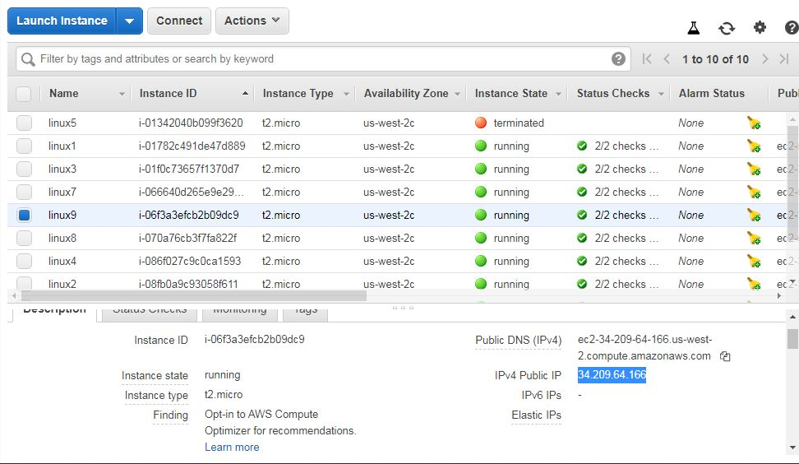

Output:

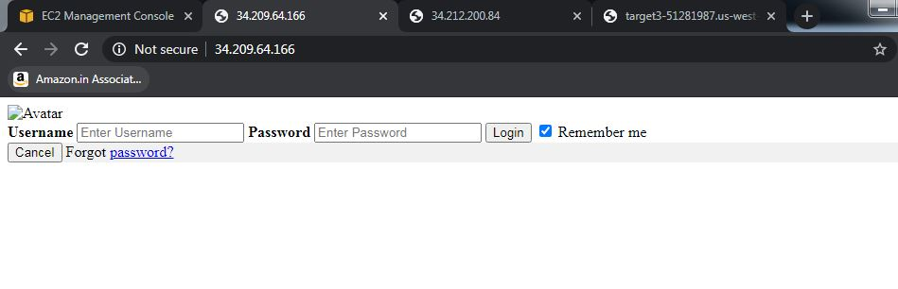

**Linux 2:**

Public IP: <http://34.212.200.84/>

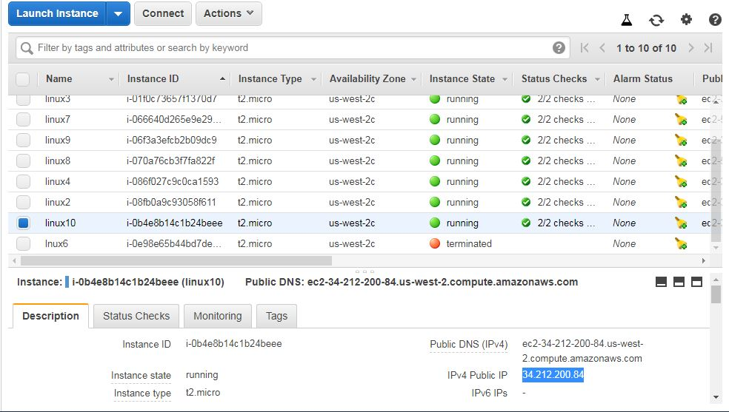

Output:

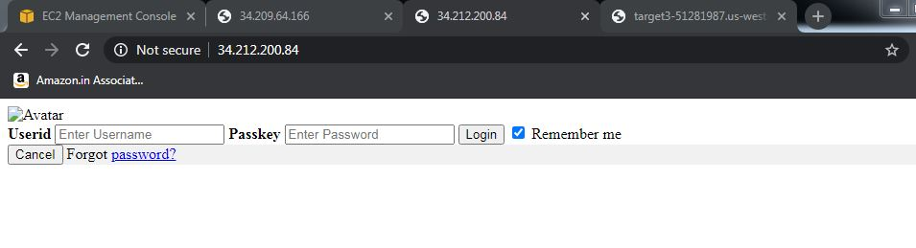

**Load Balancer:**

DNS Name: <http://target3-51281987.us-west-2.elb.amazonaws.com/>

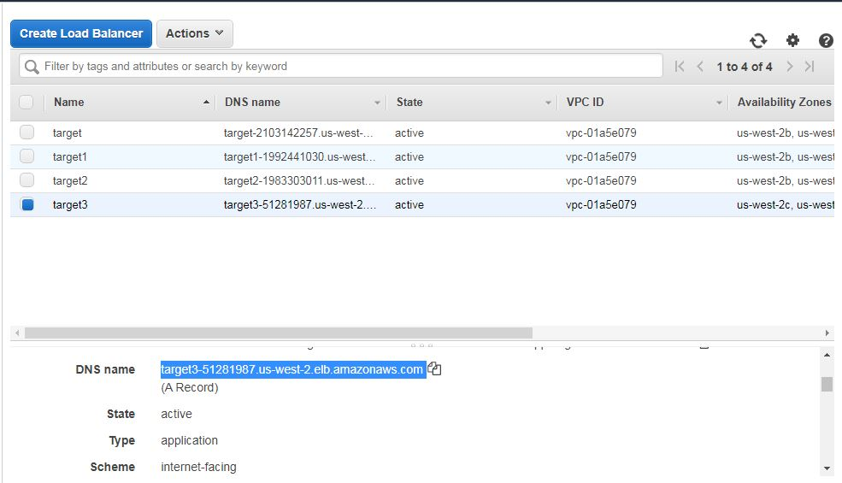

Output:

